# W1

## Why Sequence Models

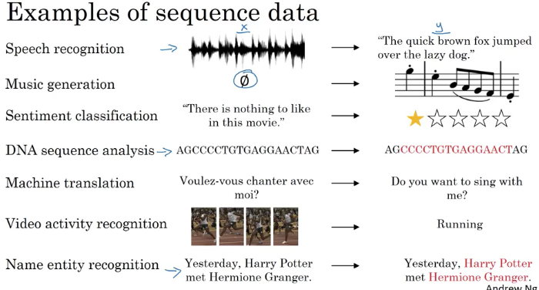

## Notation

Named_entity recognition is used by search engines to index last 24 hours news for ex

Y tells you for each of the input words is that part of a person's name. 1 if a name, 0 if not.

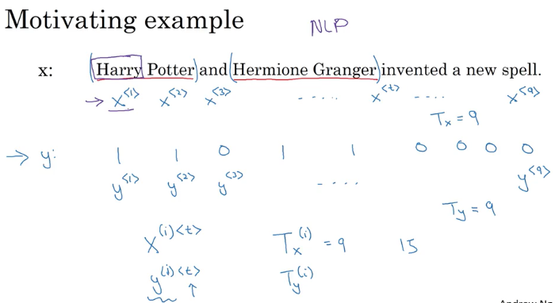

Giving to all words a number 1 to 10K for ex

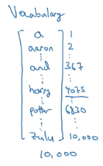

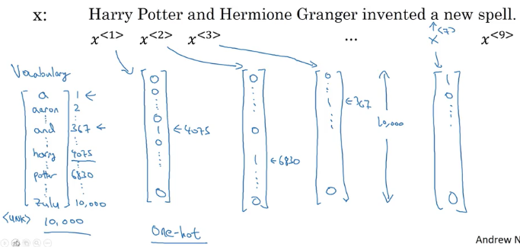

* Each word has a index starting from 1 to 10K in vocabulary vector.
* Only the word 4075 is 1 in x1 others are all zeros
* Each word has 10K vector due to vocabulary.
* <UNK> is used for words not in your vocabulary.

## Recurrent NN

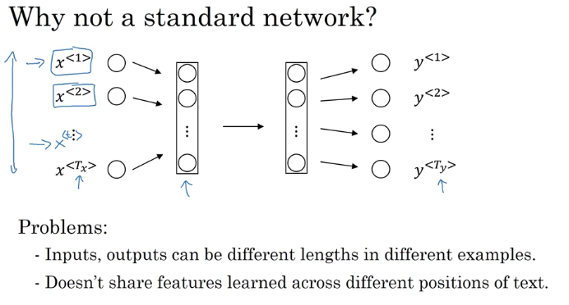

* So, you could imagine trying to take these nine input words, maybe the nine one-hot vectors and feeding them into a standard neural network, maybe a few hidden layers, and then eventually had this output the nine values zero or one that tell you whether each word is part of a person's name.
* each of these is a 10,000 dimensional one-hot vector and so this is just a very large input layer if the total input size was maximum number of words times 10,000. **A weight matrix of this first layer will end up having an enormous number of parameters**. So a recurrent neural network which we'll start to describe in the next slide does not have either of these disadvantages.
* **What a recurrent neural network does is**,
* instead of just predicting y2 using only X2, it also gets to input some information from whether the computer that time step one.
* at each time step, the recurrent neural network that passes on as activation to the next time step for it to use

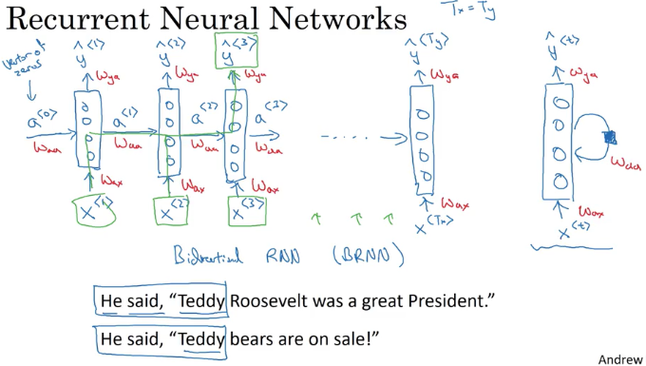

* *So given just the first three words is not possible to know for sure whether the word Teddy is part of a person's name*. In the first example, it is. In the second example, it is not. But you can't tell the difference if you look only at the first three words.
* **Waa = horizontal parameters**
* **Wax= X to hidden layer parameters**
* **Wya = governs the output predictons**
* when making the prediction for y3, it gets the information not only from X3 but also the information from x1 and x2 because the information on x1 can pass through this way to help to prediction with Y3.
* So one limitation of this particular neural network structure is that the prediction at a certain time uses inputs or ***uses information from the inputs earlier in the sequence but not information later in the sequence.***
* This is a problem, because you cannot decide Teddy is a person name or not by looking the first three words in the sentence.

## Forward Prop

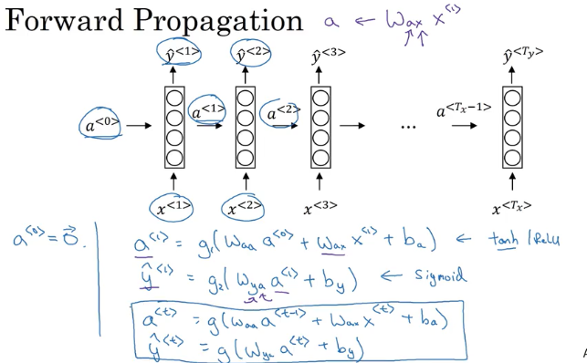

Tanh is a common choice for computing activations

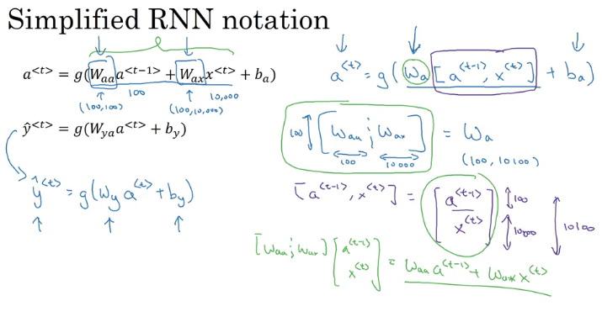

Simplifying Waa and Wax into Wa

## Backpropagation throuh time

Red lines are the backprob flow

in this back propagation procedure, the most significant message or the most significant recursive calculation is the one from atx to a0

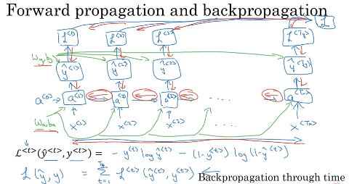

These are RNN, in which the length of the input sequence was equal to the length of the output sequence

## Different types of RNNs

Input and output may be different size like translation from English to french;there may be different number of words as output.

### Many_to_Many Architectrure

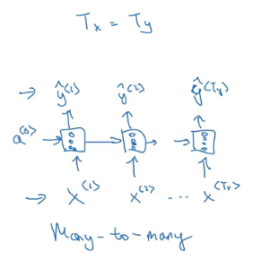

### Many to many with different size of tx and ty

**translation for ex; And** so, this that collinear network architecture has two distinct parts. There's the encoder which takes as input, say a French sentence, and then, there's is a decoder, which having read in the sentence, outputs the translation into a different language. So this would be an example of a many-to-many architecture.

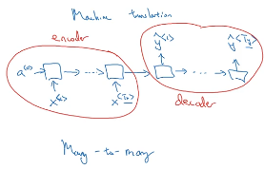

### Many_to_One architecture

For example there is a movie classification problem: from the comment text("There is nothing to like in this movie”) , you want to predict as movie is liked or not. IN this case there can only be one Y ; and that will be at the end.

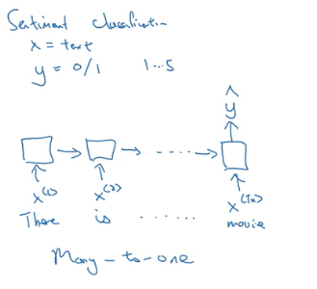

### One_to_Many Architecture

the input x could be maybe just an integer, telling it what genre of music you want or what is the first note of the music you want, and if you don't want to input anything, x could be a null input, could always be the vector zeroes as well.

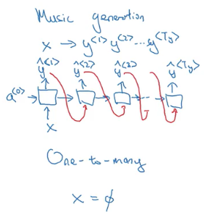

### Summary

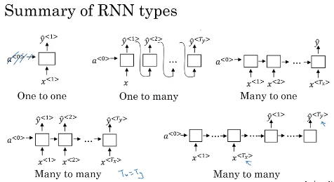

## Language model and sequence generation

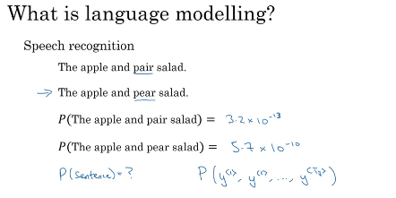

What a language model does is

* given any sentence is job is to tell you what is the probability of a sentence, of that particular sentence;
* if you want to pick up a random newspaper, open a random email or pick a random webpage or listen to the next thing someone says, the friend of you says. What is the chance that the next sentence you use somewhere out there in the world will be a particular sentence like the apple and pear salad?

## How to build language model

### Tokenize each word

* That means you would form a vocabulary
* Match every word to a specific indices
* Model when sentences end.EOS- end of sentence token

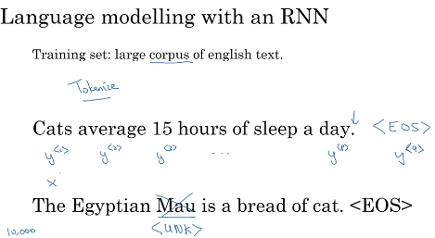

### Replace unknown words wih <UNK>

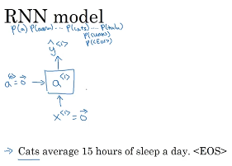

* what A1 does is it will make a soft max prediction to try to figure out what is the probability of the first words y. And so that's going to be y<1>.
* So what this step does is really, it has a soft max it's trying to predict. ***What is the probability of any word in the dictionary***? That the first one is a, what's the chance that the first word is Aaron? And then what's the chance that the first word is cats? All the way to what's the chance the first word is Zulu? Or what's the first chance that the first word is an unknown word? Or what's the first chance that the first word is the in the sentence they'll have, shouldn't have to read?
* Right, so y hat 1 is output to a soft max, it just predicts what's the chance of the first word being, whatever it ends up being. And in our example, it wind up being the word cats, so this would be a 10,000 way soft max output, if you have a 10,000-word vocabulary
* So each step in the RNN will look at some set of preceding words such as,

given the first three words, what is the distribution over the next word?

* And so this RNN learns to predict one word at a time going from left to right.
* *Next step is to compute cost*

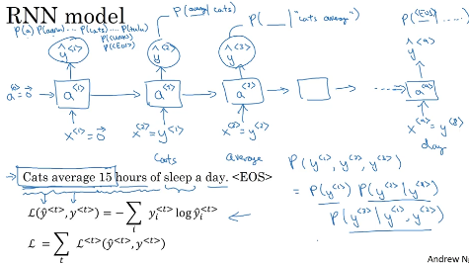

## Sampling novel sequences

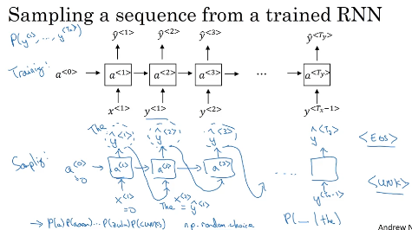

* After you train a sequence mode, you can informally get a sense of what is learned is to have a sample novel sequence
* a sequence model models the chance of any particular sequence of words as follows, and so what we like to do is sample from this distribution to generate noble sequences of words.
* So the network was trained using this structure shown at the top of pic above.
* **But to sample, you do something slightly different, so what you want to do is first sample what is the first word you want your model to generate**
* And so for that you input the usual x1 equals 0, a0 equals 0. And now your first time stamp will have some max probability over possible outputs. So what you do is you then randomly sample according to this soft max distribution.
* So what the soft max distribution gives you is it tells you what is the chance that it refers to this a, what is the chance that it refers to this Aaron? What's the chance it refers to Zulu, what is the chance that the first word is the Unknown word token. Maybe it was a chance it was a end of sentence token. And then you take this vector and use, for example, the numpy command np.random.choice to sample according to distribution defined by this vector probabilities, and that lets you sample the first words.
* Next you then go on to the second time step, and now remember that the second time step is **expecting this y1 as input.** But what you do is you then take the y1 hat that you just sampled and pass that in here as the input to the next timestep.
* This was ***word level RNN,*** you could also build ***character level RNN***

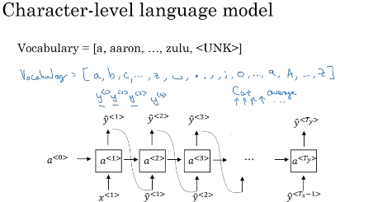

* **the main disadvantage of the character level language model is that you end up with much longer sequences**
* **computationally expensive to train**
* **trend is still using word level,** character level is not widespread; but by the computer’s development, more people starts to look at this character level algorithms

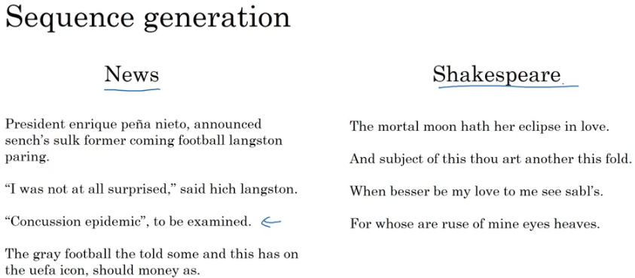

* If the model was trained on news articles, then it generates texts like that shown on the left
* If it was trained on Shakespearean text and then it generates stuff that sounds like Shakespeare could have written it.

## Vanishing gradients with RNNs

* it turns out the basics RNN we've seen so far it's not very good at capturing very long-term dependencies. Because of vanishing gradient problems.
* So this is a very, very deep neural network say, 100 layers or even much deeper than you would carry out forward prop, from left to right and then back prop. And we said that, if this is a very deep neural network, then the gradient from just output y, would have a **very hard time propagating back to affect the weights of these earlier layers**, to affect the computations in the earlier layers.
* And for an RNN with a similar problem, you have forward prop came from left to right, and then back prop, going from right to left. And it can be quite difficult, because of the same ***vanishing gradients problem, for the outputs of the errors associated with the later time steps to affect the computations that are earlier***.

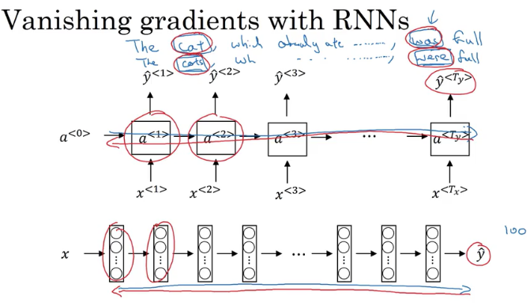

* And ***so in practice***, what this means is, ***it might be difficult to get a neural network to realize that it needs to memorize the just see a singular noun or a plural noun***, so that later on in the sequence that can generate either was or were, depending on whether it was singular or plural.
* And notice that in English, this stuff in the middle could be arbitrarily long, right? So you might need to memorize the singular/plural for a very long time before you get to use that bit of information.
* So because of this problem, the basic RNN model has many local influences, meaning that the output y^<3> is mainly influenced by values close to y^<3>. And a value here is mainly influenced by **inputs that are somewhere close So this is a weakness of the basic RNN algorithm**

## Gradient clipping

* to avoid exploding gradients(meaning taking on overly large values.)

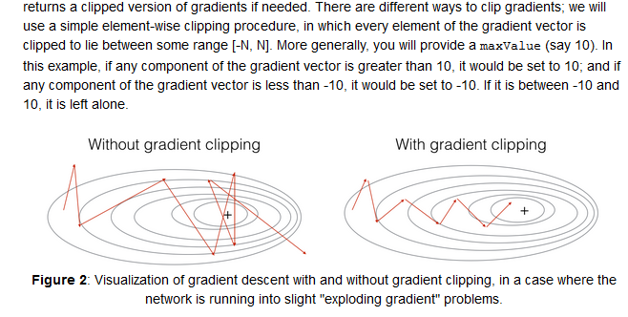

Exploding gradients, you could sort of address by just using gradient clipping, but vanishing gradients will take more work to address.(gated recurrent units )

## Gated Recurrent Unit (GRU)

* Gated Recurrent Unit is a modification to the RNN hidden layer that makes it much ***better capturing long range connections***
* ***Helps a lot with the vanishing gradient problems.***
* ***They have fewer parameters than LSTM, as they lack an output gate***
* *To solve the vanishing gradient problem of a standard RNN, GRU uses, so called, update gate and reset gate. Basically, these are two vectors which decide what information should be passed to the output. The special thing about them is that they can be trained to keep information from long ago, without washing it through time or remove information which is irrelevant to the prediction.(* [*https://towardsdatascience.com/understanding-gru-networks-2ef37df6c9be*](https://towardsdatascience.com/understanding-gru-networks-2ef37df6c9be)*)*

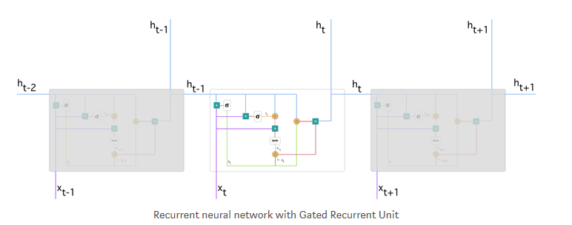

***The update gate*** *helps the model to determine how much of the past information (from previous time steps) needs to be passed along to the future.*

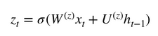

**Reset gate is used from the model to decide how much of the past information to forget. To** calculate it, we use:

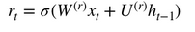

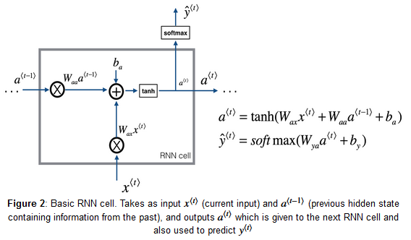

***Memory cell:*** memorizes the word cat in this example, whether it is plural or singular

symbol c : to denote the memory cell value ;

a for the output activation value

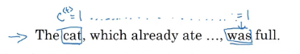

* memory cell c is going to be set to either zero or one depending on whether the is singular or plural. So because it's singular, let's say that we set this to one. And if it was plural, maybe we would set this to zero, and then the GRU unit would memorize the value of the c<t> all the way until here, where this is still equal to one and so that tells it, oh, it's singular so use the choice was. ***And the job of the gate, of gamma u, is to decide when do you update these values.***

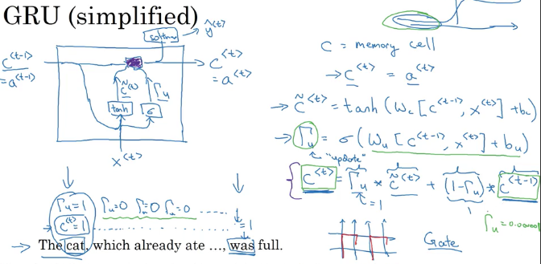

* Hopefully you've just been setting c<t> equals c<t> minus one all along. And it still memorizes the cat was singular.

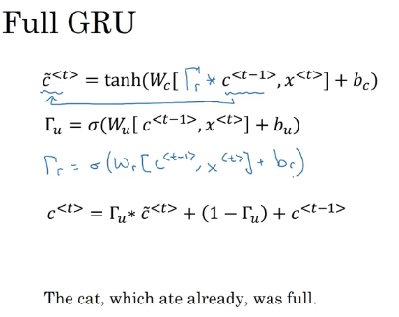

## LSTM Long Short Term Memory

A common LSTM unit is composed of a cell, **an input gate, an output gate and a forget gate**. The cell is responsible for "remembering" values over arbitrary time intervals; hence the word "memory" in LSTM. Each of the three gates can be thought of as a "conventional" artificial neuron, as in a multi-layer (or feedforward) neural network: that is, they compute an activation (using an activation function) of a weighted sum. Intuitively, they can be thought as regulators of the flow of values that goes through the connections of the LSTM; hence the denotation "gate". There are connections between these gates and the cell.

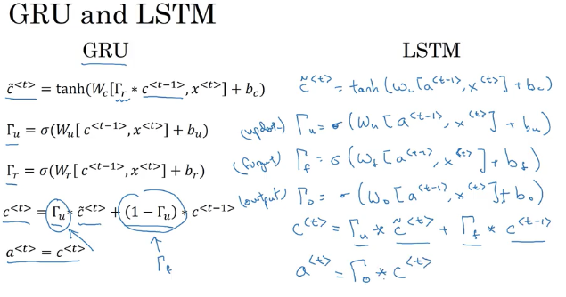

The expression long short-term refers to the fact that LSTM is a model for the short-term memory which can last for a long period of time. **An LSTM is well-suited to classify, process and predict time series given time lags of unknown size** and duration between important events. LSTMs were developed to deal with the exploding and vanishing gradient problem when training traditional RNNs. Relative insensitivity to gap length gives an advantage to LSTM over alternative RNNs, hidden Markov models and other sequence learning methods in numerous applications

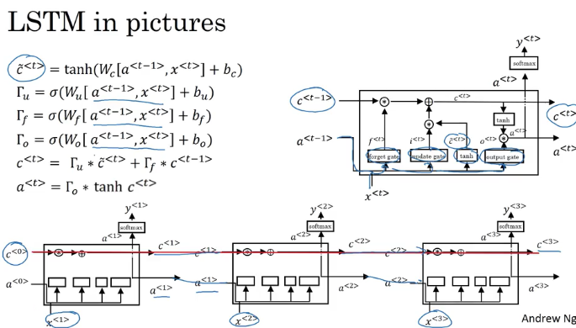

* The advantage of the **GRU** is that it's a simpler model and so it is actually easier to build a much bigger network, **it only has two gates**, so computationally, it runs a bit faster.
* So, it scales the building somewhat bigger models but the ***LSTM is more powerful and more effective since it has three gates instead of two.***

If you want to pick one to use, I think LSTM has been the historically more proven choice. So, if you had to pick one, I think most people today will still use the LSTM as the default first thing to try.

Although, I think in the last few years, GRUs had been gaining a lot of momentum and I feel like more and more teams are also using GRUs because they're a bit simpler but often work just as well. It might be easier to scale them to even bigger problems.

## Bidirectional RNN

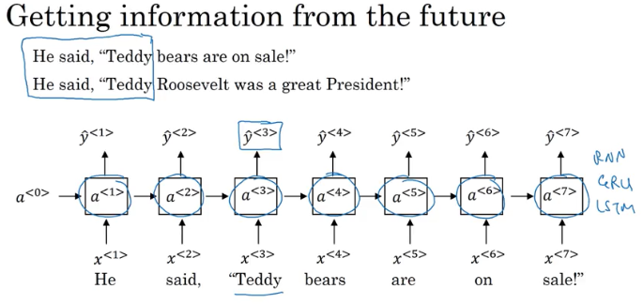

**one of the problems of unidirectional network is** that, to figure out whether the third word Teddy is a part of the person's name, **it's not enough to just look at the first part of the sentence.** So to tell, if Y three should be zero or one, you need more information than just the first three words because the first three words doesn't tell you if they'll talking about Teddy bears or talk about the former US president, Teddy Roosevelt.

So what a bidirectional RNN does or BRNN, is fix this issue.

For a lot of text with natural language processing problems, a bidirectional RNN with a LSTM appears to be commonly used.

So, if we have NLP problem and you have the complete sentence, you try to label things in the sentence, **a bidirectional RNN with LSTM blocks both forward and backward** would be a pretty views of first thing to try.

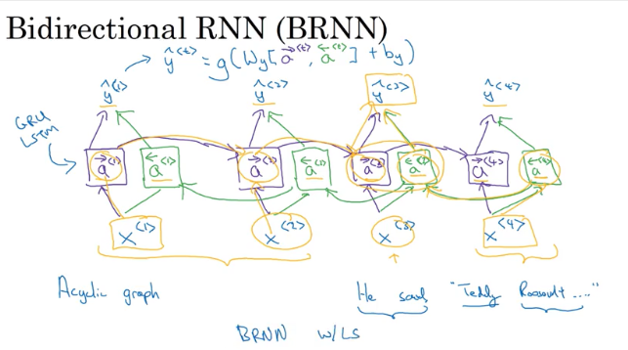

And so, given an input sequence, X1 through X4, the fourth sequence will first compute A forward1 , then use that to compute A forward 2, then A forward three, then A forward four.

Whereas, the backward sequence would start by computing A backward 4, and then go back and compute A backward 3, and then as you are computing network activation, this is not backward this is forward prop.

So this allows the prediction at time three to take as input both information from the past, as well as information from the present which goes into both the forward and the backward things at this step, as well as information from the future. So, in particular, given a phrase like, "He said, Teddy Roosevelt..." To predict whether Teddy is a part of the person's name, ***you take into account information from the past and from the future.***

The disadvantage of the bidirectional RNN is that you do need the entire sequence of data before you can make predictions anywhere

## Deep RNNs

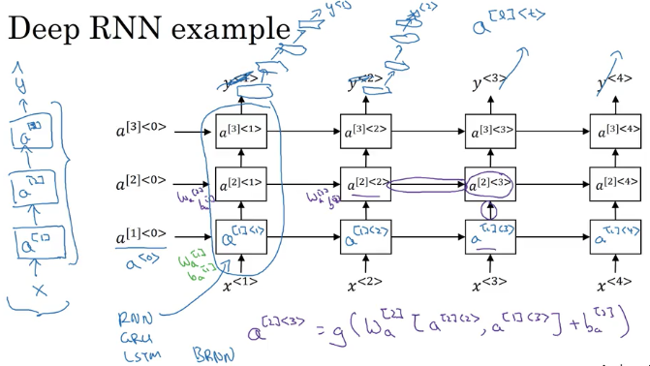

# W2

## Word Representation

**Onehot represantation**

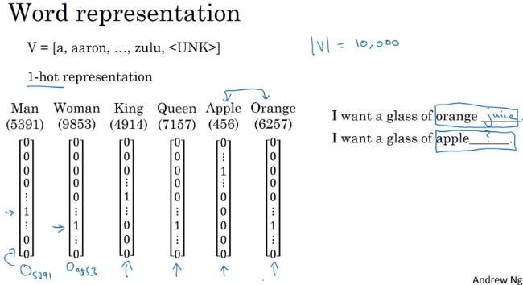

* Even if the learning algorithm has learned that I want a glass of orange juice is a likely sentence, if it sees I want a glass of apple blank. As far as it knows the relationship between apple and orange is not any closer as the relationship between any of the other words man, woman, king, queen, and orange.
* And so, it's not easy for the learning algorithm to generalize from knowing that orange juice is a popular thing, to recognizing that apple juice might also be a popular thing or a popular phrase. **And this is because the any product between any two different one-hot vector is zero.**
* If you take any two vectors say, queen and king and any product of them, the end product is zero. If you take apple and orange and any product of them, the end product is zero. And you couldn't distance between any pair of these vectors is also the same. So it just doesn't know that somehow apple and orange are much more similar than king and orange or queen and orange

**Featurized representation**

300 dimensional(features)

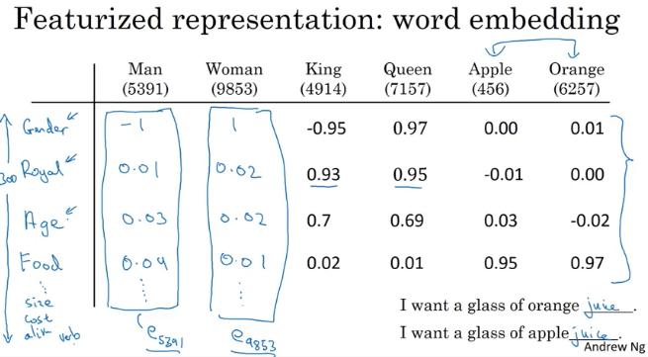

A lot of the features of apple and orange are actually the same, or take on very similar values. And so, this increases the odds of the learning algorithm that has figured out that orange juice is a thing, to also quickly figure out that apple juice is a thing. So this allows it to generalize better across different words.

We just need you to learn high dimensional feature vectors like these, *that gives a better representation than one-hot vectors for representing different words*. And the features we'll end up learning, won't have a easy to interpret interpretation like that component one is gender, component two is royal, component three is age and so on.

Exactly what they're representing will be a bit harder to figure out. But nonetheless, the featurized representations we will learn, ***will allow an algorithm to quickly figure out that apple and orange are more similar than say, king and orange or queen and orange.***

**t_SNE**

* If we're able to learn a **300 dimensional feature vector or 300 dimensional embedding** for each words, one of the popular things to do is also to take this 300 dimensional data and embed it say, in a two dimensional space so that you can visualize them.

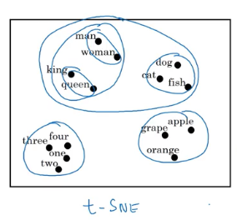 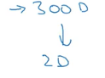

* And so, one common algorithm for doing this is the t-SNE algorithm due to Laurens van der Maaten and Geoff Hinton.
* And if you look at one of these embeddings, one of these representations, you find that words like man and woman tend to get grouped together, king and queen tend to get grouped together,

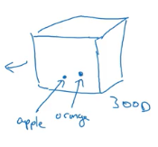

* what you do is you take every words like orange, and have a three dimensional feature vector so that word orange gets embedded to a point in this 300 dimensional space.
* And the word apple, gets embedded to a different point in this 300 dimensional space. And of course to visualize it, ***algorithms like t-SNE, map this to a much lower dimensional space,*** you can actually plot the 2D data and look at it. But that's what the term embedding comes from.
* Word embeddings has been one of the most important ideas in NLP, in Natural Language Processing.

## Using Word Embeddings

* Given a sentence like Sally Johnson is an orange farmer, hopefully, you'll figure out that Sally Johnson is a person's name, hence, the outputs 1 like that. And one way to be sure that Sally Johnson has to be a person, rather than say the name of the corporation is that you know orange farmer is a person.

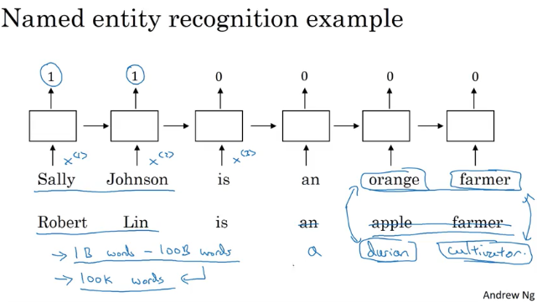

* Knowing that orange and apple are very similar will make it easier for your learning algorithm to generalize to figure out that Robert Lin is also a human, is also a person's name
* A durian is a rare type of fruit, popular in Singapore and a few other countries. But if you have a small label training set for the named entity recognition task, you might not even have seen the word durian or seen the word cultivator in your training set.
* But if you have learned a word embedding that tells you that durian is a fruit, so it's like an orange, and a cultivator, someone that cultivates is like a farmer, then you might still be generalize from having seen an orange farmer in your training set to knowing that a durian cultivator is also probably a person
* So one of the reasons that word embeddings will be able to do this is the algorithms to learning word embeddings can examine very large text corpuses, maybe found off the Internet.
* So you can examine very large data sets, maybe a billion words, maybe even up to 100 billion words would be quite reasonable. So very large training sets of just unlabeled text.And by examining tons of unlabeled text, which you can download more or less for free, you can figure out that orange and durian are similar.
* Now having discovered that orange and durian are both fruits by reading massive amounts of Internet text, what you can do is then take this word embedding and apply it to your named entity recognition task, for which you might have a much smaller training set, maybe just 100,000 words in your training set, or even much smaller.
* And so this allows you to carry out transfer learning, where you take information you've learned from huge amounts of unlabeled text that you can suck down essentially for free off the Internet to figure out that orange, apple, and durian are fruits.

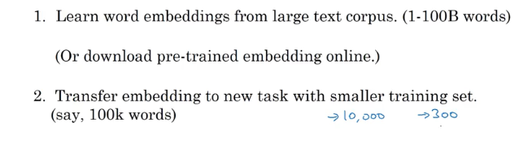

* So rather than using a 10,000 dimensional one-hot vector, you can now instead use maybe a 300 dimensional dense vector. Although the one-hot vector is fast and the 300 dimensional vector that you might learn for your embedding will be a dense vector.



* finally, as you train your model on your new task, on your named entity recognition task with a smaller label data set, one thing you can optionally do is to continue to fine tune,

continue to adjust the word embeddings with the new data. (In practice; you would do this only if you have task2 a big dataset)

## Properties of word embeddings

Used for analogy reasoning

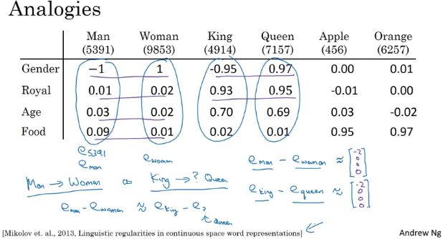

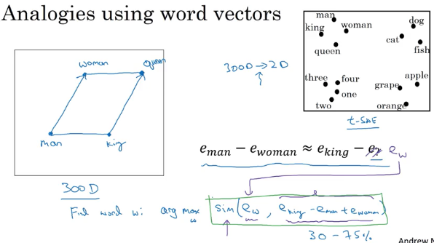

### Cosine similarity

* U and v are two vectors, looking for similarity we use cosine sim.

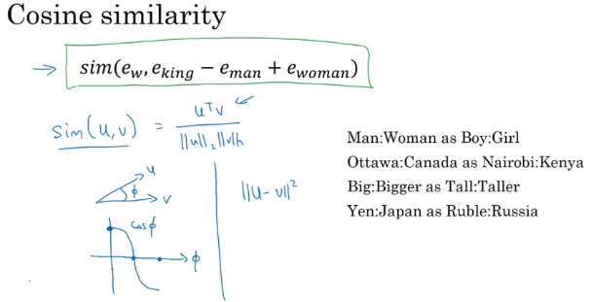

* if the angle between them is 0, then the cosine similarity is equal to 1. And if their angle is 90 degrees, the cosine similarity is 0. And then if they're 180 degrees, or pointing in completely opposite directions, it ends up being -1.

## Embedding Matrix

Matrix E : 10K vocabulary with 300 features each.

Vector e: for ex orange’s all features inside the matrix E.

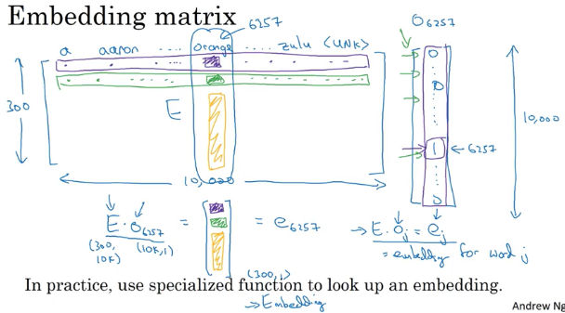

So, in this video you saw the notations were used to describe algorithms to learning these embeddings and the key terminology is this matrix capital E which contain all the embeddings for the words of the vocabulary.

## Learning Word Embeddings

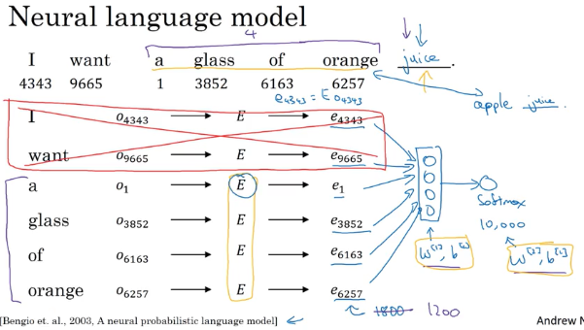

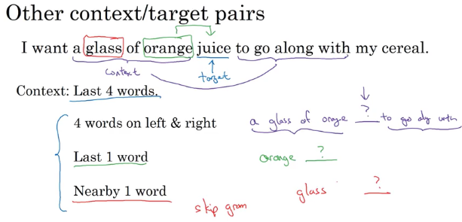

* In this video you saw how the language modeling problem which causes the pose of machines learning problem where you input the context like the last four words and predicts some target words, how posing that problem allows you to learn input word embedding

## Word2Vec

There are two versions of this Word2Vec model, the skip gram was one. and the other one is called the CBow.

### Skip-grams

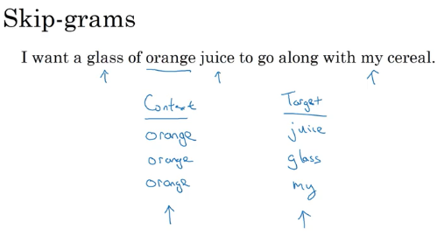

* Rather than having the context be always the last four words or the last end words immediately before the target word, what I'm going to do is, say, randomly pick a word to be the context word. And let's say we chose the word orange.
* And what we're going to do is randomly pick another word within some window. Say plus minus five words or plus minus ten words of the context word and we choose that to be target word.

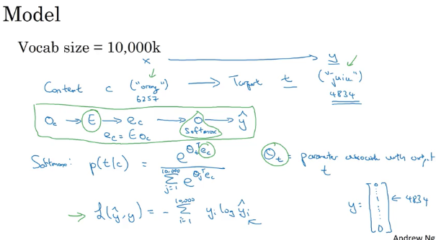

* So we use y to represent the target word. And we use a one-hot representation for y hat and y here. Then the lost would be The negative log liklihood, so sum from i equals 1 to 10,000 of yi log yi hat. So that's a usual loss for softmax where we're representing the target y as a one hot vector. So this would be a one hot vector with just 1 1 and the rest zeros. And if the target word is juice, then it'd be element 4834 from up here. That is equal to 1 and the rest will be equal to 0.
* Y hat will be a 10,000 dimensional vector output by the softmax unit with probabilities for all 10,000 possible targets words.
* ***This is called the skip-gram model because is taking as input one word like orange and then trying to predict some words skipping a few words from the left or the right side***. To predict what comes little bit before little bit after the context words.

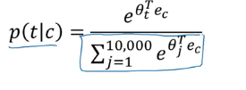

* Now, it turns out there are a couple problems with using this algorithm. And the primary problem is ***computational speed***. In particular, for the softmax model, every time you want to evaluate this probability, **you need to carry out a sum over all 10,000 words in your vocabulary**
* in fact, 10,000 is actually already that will be quite slow, but it makes even harder to scale to larger vocabularies. So there are a few solutions to this, one which you see in the literature is to use a hierarchical softmax classifer

### hierarchical softmax classifier

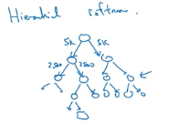

* Imagine if you have one classifier, it tells you is the target word in the first 5,000 words in the vocabulary? Or is in the second 5,000 words in the vocabulary? And lets say this binary cost that it tells you this is in the first 5,000 words, think of second class to tell you that this in the first 2,500 words of vocab or in the second 2,500 words vocab and so on.
* Until eventually you get down to classify exactly what word it is, so that the leaf of this tree, and so having a tree of classifiers like this, means that each of the retriever nodes of the tree can be just a binding classifier
* And so you don't need to sum over all 10,000 words or else it will capsize in order to make a single classification. In fact, the computational classifying tree like this scales like log of the vocab size rather than linear in vocab size
* In practice the below tree is constructed .

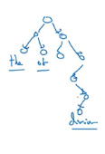

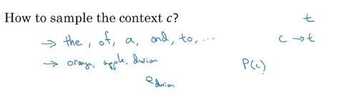

**How to sample the context c?**

* Some words are used frequently (the,of, a etc.)
* you don't want your training site to be dominated by these extremely frequently or current words, because then you spend almost all the effort updating ec, for those frequently occurring words. But you want to make sure that you spend some time updating the embedding, even for these less common words like e durian.
* In practice the distribution of words pc isn't taken just entirely uniformly at random for the training set purpose, but instead **there are different heuristics that you could use in order to balance out something from the common words together with the less common words**

### Cbow

CBow, the continuous backwards model, which takes the surrounding contexts from middle word, and uses the surrounding words to try to predict the middle word, and that algorithm also works, it has some advantages and disadvantages

But the key problem with this algorithm with the skip-gram model as presented so far is that the softmax step is very expensive to calculate because needing to sum over your entire vocabulary size into the denominator of the soft packs.

## Negative Sampling

The problem is, given a pair of words like orange and juice, we're going to predict, is this a context-target pair? So in this example, orange juice was a positive example. And how about orange and king? Well, that's a negative example,

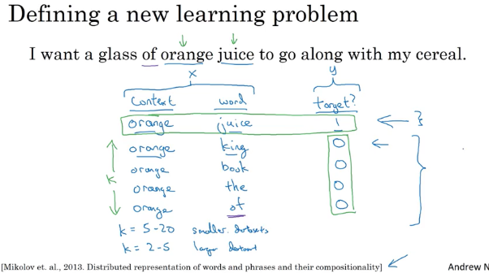

* So the problem is really given a pair of words like orange and juice, do you think they appear together?
* Do you think I got these two words by sampling two words close to each other?
* Or do you think I got them as one word from the text and one word chosen at random from the dictionary? It's really to try to distinguish between these two types of distributions from which you might sample a pair of words.So this is how you generate the training set.

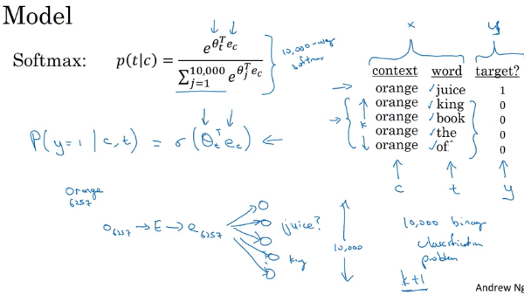

* instead of having one giant 10,000 way Softmax, which is very expensive to compute, we've instead turned it into 10,000 binary classification problems, each of which is quite cheap to compute.
* ***on every iteration, we're only going to train five of them or more generally,*** k + 1 of them, of k negative examples and one positive examples**. And this is why the computation cost of this algorithm is much lower because you're updating k + 1,** let's just say units, k + 1 binary classification problems.Which is relatively cheap to do on every iteration rather than updating a 10,000 way Softmax classifier.
* what you're doing is, ***you have a positive example, the orange and then juice. And then you will go and deliberately generate a bunch of negative examples,*** negative samplings, hence, the name negative sampling, with which to train four more of these binary classifiers.
* ***And on every iteration, you choose four different random negative words with which to train your algorithm on***

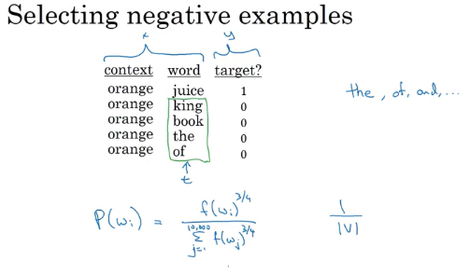

* So after having chosen the context word orange, how do you sample these words to generate the negative examples?
  + So one thing you could do is sample the words in the middle, the candidate target words. One thing you could do is sample it according to the empirical frequency of words in your corpus. So just sample it according to how often different words appears. But the problem with that is that you end up with a very high representation of words like the, of, and, and so on.
  + One other extreme would be to say, you use 1 over the vocab size, sample the negative examples uniformly at random, but that's also very non-representative of the distribution of English words.
  + So the authors, Mikolov et al, reported that empirically, what they found to work best was to take this heuristic value, which is a little bit in between the two extremes of sampling from the empirical frequencies, meaning from whatever's the observed distribution in English text to the uniform distribution. *And what they did was they sampled proportional to their frequency of a word to the power of three-fourths. So if f of wi is the observed frequency of a particular word in the English language or in your training set corpus*, then by taking it to the power of three-fourths, this is somewhere in-between the extreme of taking uniform distribution. And the other extreme of just taking whatever was the observed distribution in your training set.

## GloVe Word Vectors

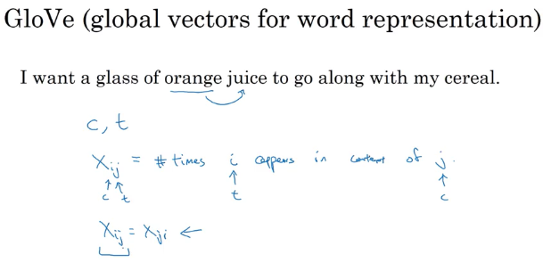

So, X_ij is a count that captures how often do **words i and j appear with each other**, or close to each other.

So what the GloVe model does is, it optimizes the following.

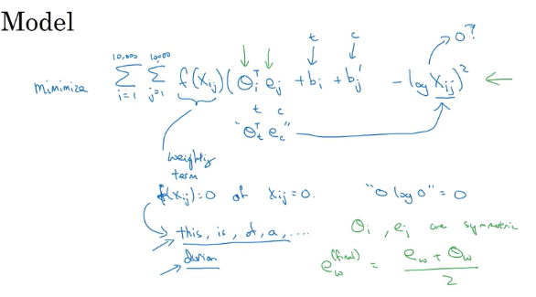

So you just want to learn vectors, so that their end product is a good predictor for how often the two words occur together.

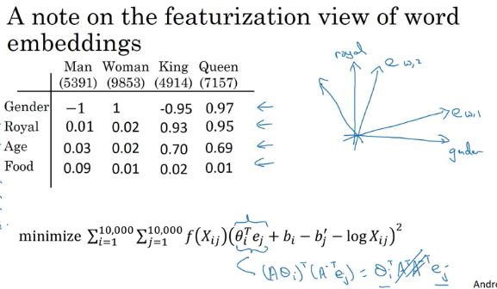

## Sentiment Classification

* Sentiment classification is the task of looking at a piece of text and telling if someone likes or dislikes the thing they're talking about.
* One of the challenges of sentiment classification is you might not have a huge label training set for it. But with word embeddings, you're able to build good sentiment classifiers even with only modest-size label training sets.

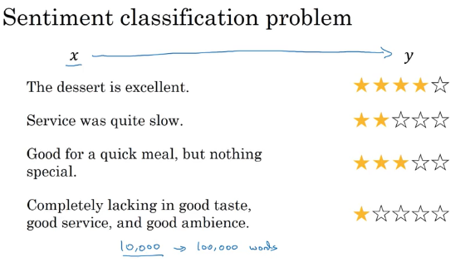

* there's O8928 which is a one-hot vector multiplied by the embedding matrix E, which can learn from a much larger text corpus. It can learn in embedding from, say, a billion words or a hundred billion words, and use that to extract out the embedding vector(e) for the word "the", and then do the same for "dessert", do the same for "is" and do the same for "excellent".

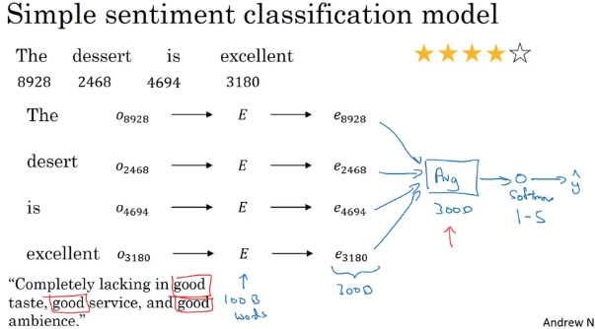

* And if this was trained on a very large data set, like a hundred billion words, then this allows you to take a lot of knowledge even from infrequent words and apply them to your problem, even words that weren't in your labeled training set.
* Output softmax as 1 star to 5 star selection. 5 possible outcomes.
* So notice that by using the average operation here, this particular algorithm works for reviews that are short or long because even if a review that is 100 words long, you can just sum or average all the feature vectors for all hundred words and so that gives you a representation, a 300-dimensional feature representation, that you can then pass into your sentiment classifier.
* So this average will work decently well. And what it does is it really averages the meanings of all the words or sums the meaning of all the words in your example.
* So one of the problems with this algorithm is it ignores word order in particular, this is a very negative review, "Completely lacking in good taste, good service, and good ambiance". But the word good appears a lot. This is a lot. Good, good, good. **So if you use an algorithm like this that ignores word order and just sums or averages all of the embeddings for the different words,** then you end up having a lot of the representation of good in your final feature vecto**r** and ***your classifier will probably think this is a good review even though this is actually very hars****h*. This is a one-star review.
* So here's a more sophisticated model which is that, instead of just summing all of your word embeddings, you can instead use a RNN for sentiment classification.

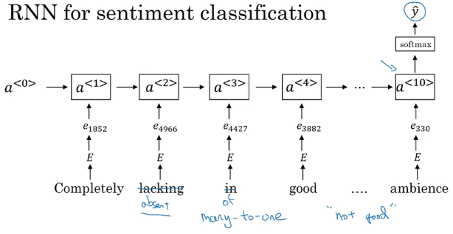

* The job of the RNN is to then compute the representation at the last time step that allows you to predict Y-hat. So this is an example of a many-to-one RNN architecture
* it will be much better at taking word sequence into account and realize that "things are
* lacking in good taste" is a negative review and "not good" a negative review unlike the previous algorithm, which just sums everything together into a big-word vector mush and doesn't realize that "not good" has a very different meaning than the words "good" or "lacking in good taste" and so on.

# W3

## Basic Models

### Sequence to Sequence model

Translating from french to english

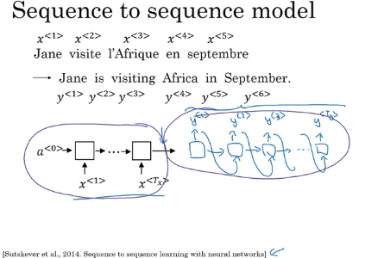

First, let's have a network, which we're going to call the **encoder network** be built as a RNN, and this could be a GRU and LSTM, feed in the input French words one word at a time

After that, you can build a decoder network which I'm going to draw here, which takes as input the encoding output by the encoder network shown in black on the left, and then can be trained to output the translation **one word at a time** until eventually it outputs say, the end of sequence or end the sentence token upon which the decoder stops and as usual we could take the generated tokens and feed them to the next set of words in the sequence like we 're doing before when synthesizing text using the language model.

If you train the model to input a French sentence and output the corresponding English translation, this will actually work decently well, And this model simply uses an encoder network, whose job it is to find an encoding of the input French sentence and then use a decoder network to then generate the corresponding English translation

### Image Captioning

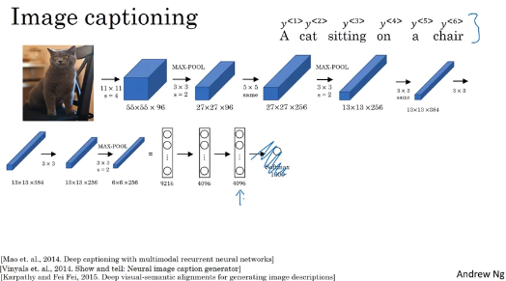

So, this is actually the AlexNet architecture and if we get rid of this final Softmax unit, the pre-trained AlexNet can give you a 4096-dimensional feature vector of which to represent this picture of a cat. And so this pre-trained network can be the encoder network for the image and you now have a 4096-dimensional vector that represents the image

You can then take this and feed it to an RNN, whose job it is to generate the caption one word at a time.

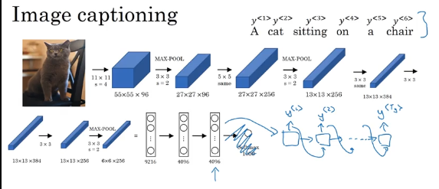

So similar to what we saw with machine translation translating from French to English, you can now input a feature vector describing the input and then have it generate an output sequence or output set of words one word at a time. And this actually works pretty well for image captioning, especially if the caption you want to generate is not too long

## Picking the most likely sentence

In language modeling, this was the network we had built in the first week. And this model allows you to estimate the probability of a sentence. That's what a language model does

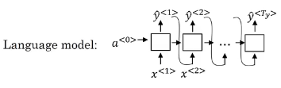

The machine translation model looks as follows:

Green as encoding network, whereas purple is the decoding network,

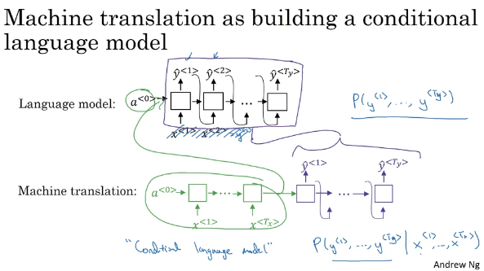

So what the machine translation model is, is very similar to the language model, except that instead of always **starting along with the vector of all zeros, it instead has an encoded network that figures out some representation for the input sentenc**e, and it takes that input sentence and starts off the decoded network with representation of the input sentence rather than with the representation of all zeros. So, that's why I call this a conditional language model, and instead of modeling the probability of any sentence, it is now modeling the probability of, say, the output English translation, conditions on some input French sentence.

So in other words, **you're trying to estimate the probability of an English translation**. Like, what's the chance that the translation is "Jane is visiting Africa in September," but conditions on the input French sentence like, "Jane visite I'Afrique en septembre." So, this is really the probability of an English sentence conditions on an input French sentence which is why it is a conditional language model

Now, if you want to apply this model to actually translate a sentence from French into English, given this input French sentence, the model might tell you what is the probability of difference in corresponding English translations.

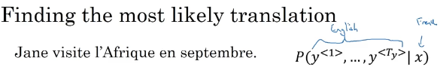

So, x is the French sentence, "Jane visite l'Afrique en septembre." And, this now tells you what is the probability of different English translations of that French input.

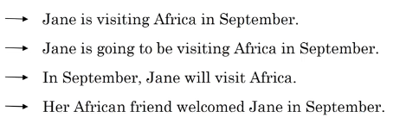

And, what **you do not want is to sample outputs at random.** If you sample words from this distribution, p of y given x, maybe one time you get a pretty good translation, "Jane is visiting Africa in September." But, maybe another time you get a different translation, "Jane is going to be visiting Africa in September. " Which sounds a little awkward but is not a terrible translation, just not the best one.

So, when you're using this model for machine translation, you're not trying to sample at random from this distribution. Instead, what you would like is to find the English sentence, y, that maximizes that conditional probability.

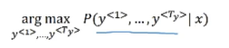

So in developing a machine translation system, one of the things you need to do is come up with an algorithm that can actually find the value of y that maximizes this term over here. The most common algorithm for doing this is called beam search,

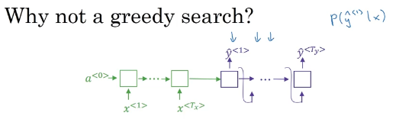

Greedy search is an algorithm from computer science which says to generate the first word just pick whatever is the most likely first word according to your conditional language model. Going to your machine translation model and then after having picked the first word, you then pick whatever is the second word that seems most likely, then pick the third word that seems most likely. This algorithm is called greedy search.

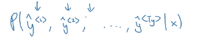

And, what you would really like is to pick the entire sequence of words, y1, y2, up to yTy, that's there, that maximizes the joint probability of that whole thing. And it turns out that the greedy approach, where you just pick the best first word, and then, after having picked the best first word, try to pick the best second word, and then, after that, try to pick the best third word, that approach **doesn't really work.**

**To demonstrate that:**

let's consider the following two translations.

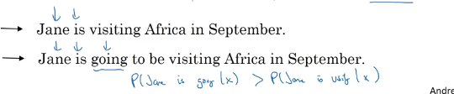

The first one is a better translation, so hopefully, in our machine translation model, it will say that p of y given x is higher for the first sentence. It's just a better, more succinct translation of the French input. The second one is not a bad translation, it's just more verbose, it has more unnecessary words

But, if the algorithm has picked "Jane is" as the first two words, because "going" is a more common English word, probably the chance of "Jane is going," given the French input, this might actually be higher than the chance of "Jane is visiting," given the French sentence. So, it's quite possible that if you just pick the third word based on whatever maximizes the probability of just the first three words, you end up choosing option number two

But, this ultimately ends up resulting in a less optimal sentence, in a less good sentence as measured by this model for p of y given x. I know this was may be a slightly hand-wavey argument, but, this is an example of a broader phenomenon, where if you want to find the sequence of words, y1, y2, all the way up to the final word that together maximize the probability, it's not always optimal to just pick one word at a time. And, of course, the total number of combinations of words in the English sentence is exponentially larger.

So, if you have just 10,000 words in a dictionary and if you're contemplating translations that are up to ten words long, then there are 10000 to the tenth possible sentences that are ten words long. Picking words from the vocabulary size, the dictionary size of 10000 words. So, this is just a huge space of possible sentences, and it's impossible to rate them all, which is why the most common thing to do is use an approximate search algorithm.

So what an **approximate search algorithm** does, is it will try, it won't always succeed, but it will to pick the sentence, y, that maximizes that conditional probability. And, even though it's not guaranteed to find the value of y that maximizes this, it usually does a good enough job.

So, to summarize,

in this video, you saw how machine translation can be posed as a conditional language modeling problem. But one major difference between this and the earlier language modeling problems is rather than wanting to generate a sentence at random, **you may want to try to find the most likely English sentence, most likely English translation**. But the set of all English sentences of a certain length is too large to exhaustively enumerate. So, we have to resort to a search algorithm

## Beam Search

**Choosing the best probable words(**how many words is dependent to beam width**) from all dictionary; from the first word to second word and so on.**

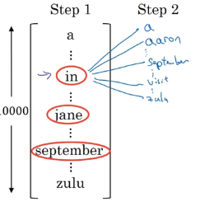

First Step

The first thing Beam search has to do is try to pick the first words of the English translation, that's going to operate. So here I've listed, say, 10,000 words into vocabulary. So, in the first step of Beam Search, I use this network fragment with the coalition in green and decoalition in purple, to try to evaluate what is the probability of that for a square. So, what's the probability of the first output y, given the input sentence x gives the French input.

So, whereas greedy search will pick only the one most likely words and move on, Beam Search instead can **consider multiple alternatives**.

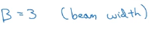So, the Beam Search algorithm has a parameter called B, which is called the beam width and for this example I'm going to set the beam width to be with the three. And what this means is Beam search will cause that not just one possibility but consider three at the time

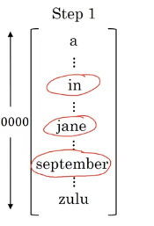

let's say evaluating this probability over different choices the first words, it finds that the choices in, Jane and September are the most likely three possibilities for the first words in the English outputs. Then Beam search will stowaway in computer memory that it wants to try all of three of these words, and if the beam width parameter were said differently, the beam width parameter was 10, then we keep track of not just three but of the ten, most likely possible choices for the first word.

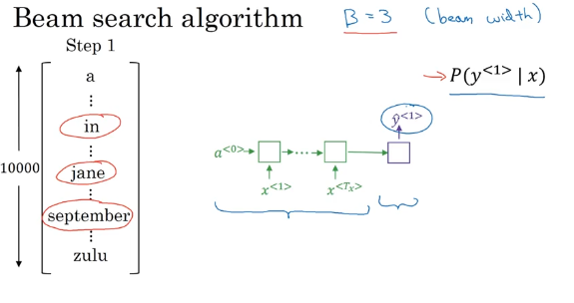

So, to be clear in order to perform this **first step of Beam search**, what you need to do is run the input French sentence through this encoder network and then this first step will then decode the network, **this is a softmax output overall 10,000 possibilities.** Then you would take those 10,000 possible outputs and **keep in memory which were the top three**

Second step



Having picked in, Jane and September as the three most likely choice of the first word, what Beam search will do now, is for each of these three choices consider what should be the second word, so after "in" maybe a second word is "a" or maybe as Aaron, I'm just listing words from the vocabulary, from the dictionary or somewhere down the list will be September, somewhere down the list there's visit and then all the way to z and then the last word is zulu. So, to evaluate the probability of second word, it will use this new network fragments where is coder in green and for the decoder portion when trying to decide what comes after in. Remember the decoder first outputs, y hat one.

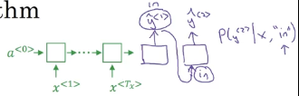

So, I'm going to set to this y hat one to the word "in" as it goes back in.

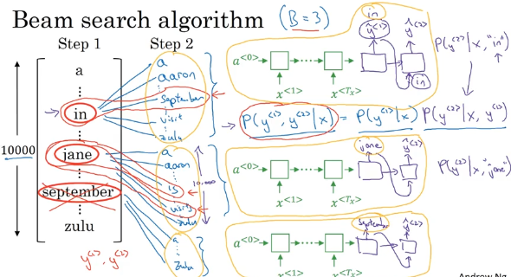

Because the beam width is 3, in the second step you will choose the most likely 3 out of 30K possibilities(30K: because of first layer’s 3 words times the 10K dictionary for each one )

The red drawings are the most candidates of 1.st and 2.nd layers.

Just want to notice that because of beam width is equal to three, every step you instantiate three copies of the network to evaluate these partial sentence fragments and the output. And it's because of beam width is equal to three that you have three copies of the network with different choices for the first words, but these three copies of the network can be very efficiently used to evaluate all 30,000 options for the second word. So just don't instantiate 30,000 copies of the network or three copies of the network to very quickly evaluate all 10,000 possible outputs at that softmax output say for Y2.

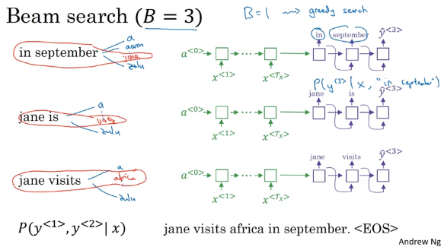

## Refinement to Beam Search

### Length Normalization

Beam search is about maximizing this probability

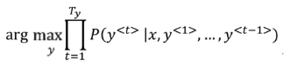

if you're implementing these, these probabilities(Py1 to Py t) below are all numbers less than 1.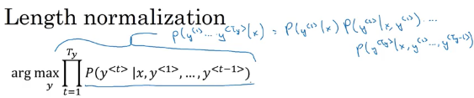Now, Often they're much less than 1. And multiplying a lot of numbers less than 1 will result in a tiny, tiny, tiny number, which can result in numerical underflow.

Meaning that it's too small for the floating part representation in your computer to store accurately.

So in practice, instead of **maximizing this product, we will take logs**.

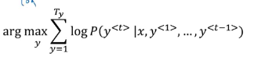

**So by taking logs**, you end up with a **more numerically stable algorithm that is less prone to rounding errors**, numerical rounding errors, or to really numerical underflow. And because the log function, that's the logarithmic function, this is strictly monotonically increasing function, maximizing P(y).

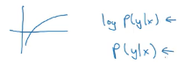

In most implementations, you keep track of the sum of logs of the probabilities rather than the protocol of probabilities

Now, there's one other change to this objective function that makes the machine translation algorithm work even better.

if you have a very long sentence, the probability of that sentence is going to be low,(because of multiplying all probs

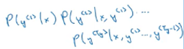

And so this objective function has an undesirable effect, that maybe it unnaturally tends to prefer very short translations. It tends to prefer very short outputs.

Because the probability of a short sentence is determined just by multiplying fewer of these numbers are less than 1.And so the product would just be not quite as small.

And by the way, the same thing is true for log function. The log of our probability is always less than or equal to 1. You're actually in this range of the log. So the more terms you have together, the more negative this thing becomes.

Ther is one other change to the algorithm that makes it work better. Normalize the formula by the number of words in your translation

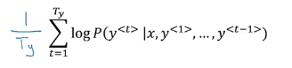

And so this takes the average of the log of the probability of each word. And this significantly reduces the penalty for outputting longer translations

In practice, you use a softer version with alpha.

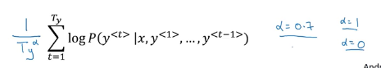

If alpha was equal to 1, then yeah, completely normalizing by length. If alpha was equal to 0, then, well, Ty to the 0 would be 1, then you're just not normalizing at all.

So just to wrap up how you run beam search,

* as you run beam search, you see a lot of sentences with length equal 1, a lot of sentences with length equal 2, a lot of sentences with length equals 3 and so on.. And maybe you run beam search for 30 steps and you consider output sentences up to length 30, let's say.
* And so with beam = 3, you will be keeping track of the top three possibilities for each of these possible sentence lengths, 1, 2, 3, 4 and so on, up to 30.
* Then, you would look at all of the output sentences and score them against this score.(above formula)
* And so you can take your top sentences and just compute this objective function on the sentences that you have seen through the beam search process.
* And then finally, of all of these sentences that you validate this way, you pick the one that achieves the highest value on this normalized log probability objective. Sometimes it's called a **normalized log likelihood objective**. And then that would be the final translation, your outputs.

how do you choose the beam width B?

* The larger B is, the more possibilities you're considering, and does the better the sentence you probably find. But the larger B is, the more computationally expensive your algorithm is, because you're also keeping a lot more possibilities around.

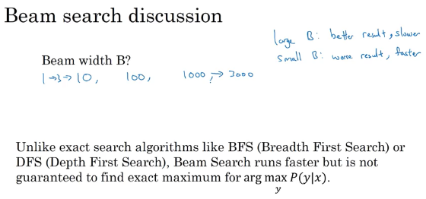

So here are the pros and cons of setting B to be very large versus very small.

* If the beam width is very large, then you consider a lot of possibilities, and so you tend to get a better result because you are consuming a lot of different options, but it will be slower. And the memory requirements will also grow, will also be compositionally slower.
* Whereas if you use a very small beam width, then you get a worse result because you're just keeping less possibilities in mind as the algorithm is running. But you get a result faster and the memory requirements will also be lower

So I would say try other variety of values of B as you work through your application. But when B gets very large, there is often diminishing returns.

## Error Analysis in Beam Search

Now, beam search is an approximate search algorithm, also called a heuristic search algorithm. And so it doesn't always output the most likely sentence. It's only keeping track of B equals 3 or 10 or 100 top possibilities. So what if beam search makes a mistake?

Here you'll learn how error analysis interacts with beam search and how you can figure out whether it is the beam search algorithm that's causing problems and worth spending time on. Or whether it might be your RNN model that is causing problems and worth spending time on

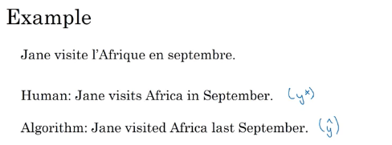

Let's say that in your machine translation dev set, your development set, the human provided this translation and Jane visits Africa in September, and I'm going to call this y*. So it is a pretty good translation written by a human.

Then let's say that when you run beam search on your learned RNN model and your learned translation model, it ends up with this translation, which we will call y-hat, Jane visited Africa last September, which is a much worse translation of the French sentence. It actually changes the meaning, so it's not a good translation.

Now, your model has two main components.

* There is a neural network model, the sequence to sequence model. We shall just call this your RNN model. It's really an encoder and a decoder.
* And you have your beam search algorithm, which you're running with some beam width b.

And wouldn't it be nice if you could attribute this error, this not very good translation, to one of these two components? Was it the RNN or really the neural network that is more to blame, or is it the beam search algorithm, that is more to blame?

And what you saw in the third course of the sequence is that it's always tempting to collect more training data that never hurts. So in similar way, it's always tempting to increase the beam width that never hurts or pretty much never hurts.

But just as getting more training data by itself might not get you to the level of performance you want. In the same way, increasing the beam width by itself might not get you to where you want to go.

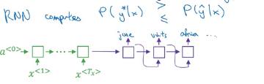

How do you decide whether or not improving the search algorithm is a good use of your time?

RNN: the encoder and the decoder does the following:

* Computes p(y*|x) and p(yhat| x)
* Compares the two to see which is bigger
* According to below cases, you decide what to do. Beam or RNN is at fault.

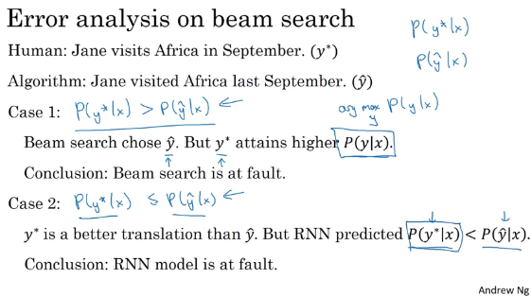

**In case 1** , P(y* | x) => P(y-hat | x) So what this allows you to conclude is **beam search is failing to actually give you the value of y that maximizes P**(y given x) because the one job that beam search had was to find the value of y that makes this really big. But it chose y-hat, the y* actually gets a much bigger value. **So in this case, you could conclude that beam search is at fault.**

**In case 2**, P(y* | x) <= P(y-hat | x) And then either this or this has gotta be true. So either case 1 or case 2 has to hold true. What do you conclude under case 2? Well, in our example, y* is a better translation than y-hat. But according to the RNN, P(y*) is less than P(y-hat), so saying that y* is a less likely output than y-hat. So in this case, it seems that the RNN model is at fault and **it might be worth spending more time working on the RNN.**

So the error analysis process looks as follows. You go through the development set and find the mistakes that the algorithm made in the development set.

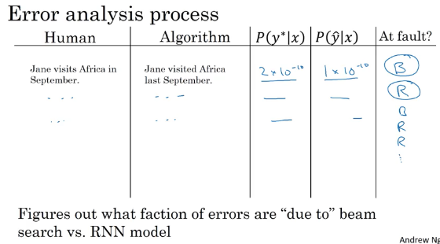

if you find that **beam search is responsible for a lot of errors**, then maybe is we're working hard to **increase the beam width**.

Whereas in contrast, if you find that the **RNN model is at fault**, then you could do a deeper layer of analysis to try to figure out if you want to add regularization, or get more training data, or try a different network architecture, or something else

## Bleu Score

One of the challenges of machine translation is that, given a French sentence, there could be multiple English translations that are equally good translations of that French sentence. So how do you evaluate a machine translation system if there are multiple equally good answers, unlike, say, image recognition where there's one right answer? You just measure accuracy. If there are multiple great answers, how do you measure accuracy? The way this is done conventionally is through something called the BLEU score.

What the **BLEU score does** is given a machine generated translation, **it allows you to automatically compute a score that measures how good is that machine translation**. And the intuition is so long as the machine generated translation is pretty close to any of the references provided by humans, then it will get a **high BLEU score.**

BLEU stands for Bilingual evaluation understudy(in theater world, understudy is someone that learns the role of a more senior actor so they can take over the role if necessary)

And motivation for BLEU is that, whereas you could ask human evaluators to evaluate the machine translation system, the BLEU score is an understudy, could be a substitute for having humans evaluate every output of a machine translation system.

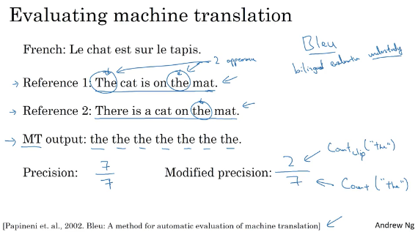

* Ref1 and ref2 is human generated references; provided as part of test set.
* MT: Machine translation of sentence. In this example(a terrible translation☺) there are 7 the generated.
* with a modified precision, we will say that, it gets a score of 2 out of 7, because out of 7 words, we'll give it a 2 credits for appearing.(the word)
* this was isolated version meaning looking at one word a time.

bigrams: pairs of words.

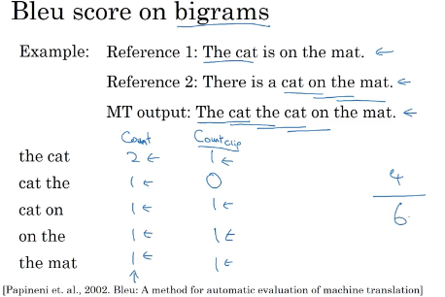

Count column : bigrams appearance in MT output,

Count-clip : bigrams in refs

Count/count_clip= 4/6 => **modified precision value**

Formula:

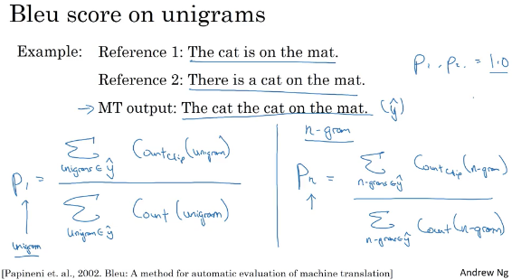

Unigram for one word ; n_gram for multiple word

So to get a modified precision of 1.0, MT output have to be exactly equal to one of the references.

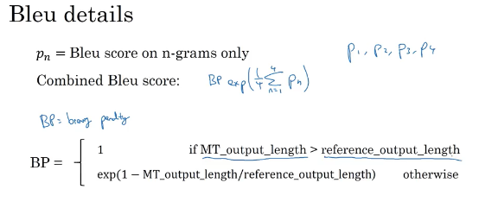

we don't want translations that are very short. So the BP, or the **brevity penalty**, is an adjustment factor that penalizes translation systems that output translations that are too short.

You saw the importance of having a single real number evaluation metric. Because it allows you to try out two ideas, see which one achieves a higher score, and then try to stick with the one that achieved the higher score. So the reason the BLEU score was revolutionary for machine translation was because this gave a pretty good, by no means perfect, but pretty good single real number evaluation metric. And so that accelerated the progress of the entire field of machine translation

Today, BLEU score is used to evaluate many systems that generate text, such as machine translation systems, as well as NN generated image caption. And then use the BLEU score to see how much that overlaps with maybe a reference caption or multiple reference captions that were generated by people.

So the BLEU score is a useful single real number evaluation metric to use whenever you want your algorithm to generate a piece of text. And you want to see whether it has similar meaning as a reference piece of text generated by humans.

This is not used for speech recognition, because in speech recognition, there's usually one ground truth. And you just use other measures to see if you got the speech transcription on pretty much, exactly word for word correct. But for things like image captioning, and multiple captions for a picture, it could be about equally good or for machine translations. There are multiple translations, but equally good. The BLEU score gives you a way to evaluate that automatically and therefore speed up your development

## Attention Model Intitution

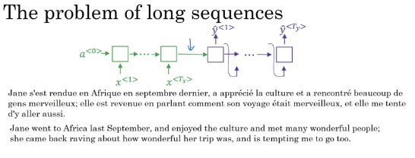

Get a very long French sentence like this. What we are asking this green encoder in your network to do is, to read in the whole sentence and then memorize the whole sentences and store it in the activations conveyed here. Then for the purple network, the decoder network till then generate the English translation

**the way a human translator** would translate this sentence is not to first read the whole French sentence and then memorize the whole thing and then regurgitate an English sentence from scratch. Instead, what the human translator would do is read the first part of it, maybe generate part of the translation. Look at the second part, generate a few more words, look at a few more words, generate a few more words and so on.**You kind of work part by part through the sentence**, because it's just really difficult to memorize the whole long sentence like that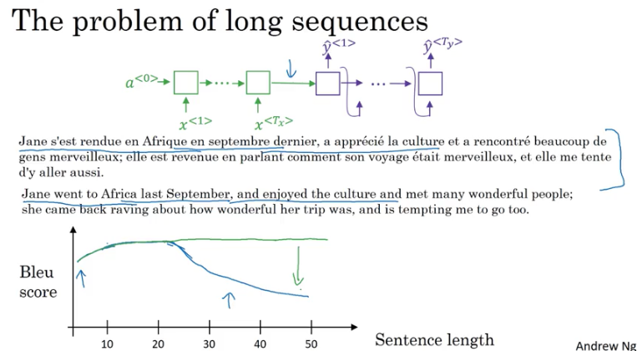

Encoder-Decoder architecture works quite well for short sentences, so we might achieve a relatively high Bleu score, but for very long sentences, maybe longer than 30 or 40 words, the performance comes down.

**The Attention Model** which translates maybe a bit more like humans might**, looking at part of the sentence at a time** and with an Attention Model, machine translation systems performance can look like the green line above.

1st word’s translation to English

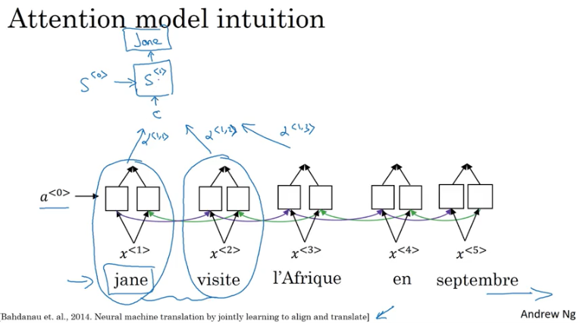

Now, the question is, when you're trying to generate this first word, this output, what part of the input French sentence should you be looking at?

* Seems like you should be looking primarily at this first word, maybe a few other words close by, but you don't need to be looking way at the end of the sentence.
* What the Attention Model would be computing is a set of attention weights and we're going to use **Alpha one**, one to denote when you're generating the first words, **how much should you be paying attention to this first piece of information here.(the first french word)**
* And then we'll also come up with a second that's called Attention Weight, Alpha one, two which tells us what we're trying to compute the first work of Jane, how much attention we're paying to this second work from the inputs and so on and the Alpha one, three and so on,
* And together this will tell us what is exactly the context from denoter C that we should be paying attention to, and that is input to this R and N unit to then try to generate the first words. That's one step of the RNN

2nd word’s translation

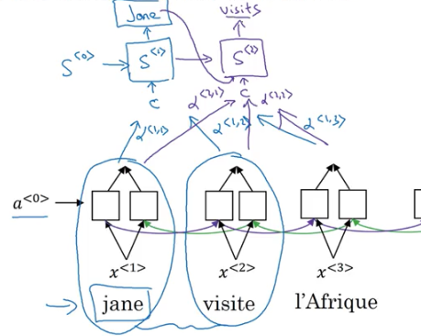

3rd word

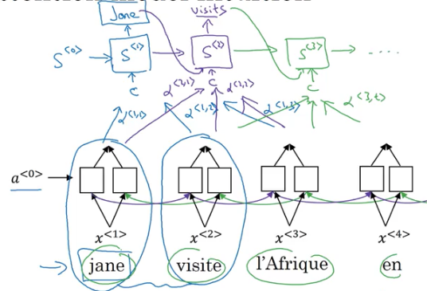

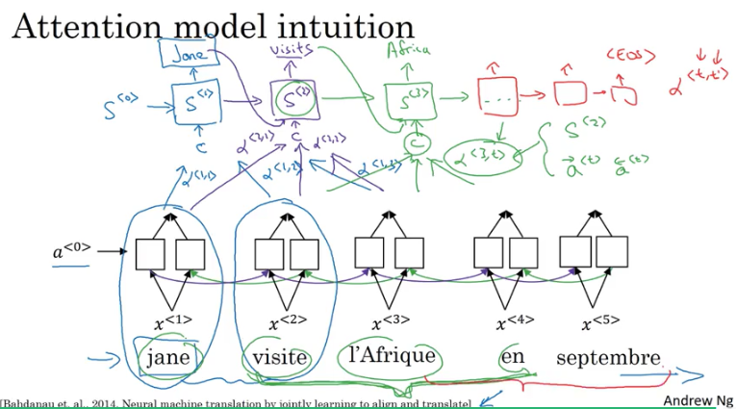

Activations for each word is bidirectional, for word Jane there are two a’s. a1 for fwd, a1 bckwrd.

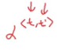 => Alpha T.T. Prime that tells it, when you're trying to generate the t_English word, how much should you be paying attention to the t_ prime French words.

And this allows it on every time step to look only maybe within a local window of the French sentence to pay attention to, when generating a specific English word.(bidirectional affect)

* s<0> ,s<1>.. stands for activations for output english words.

## Attention Model

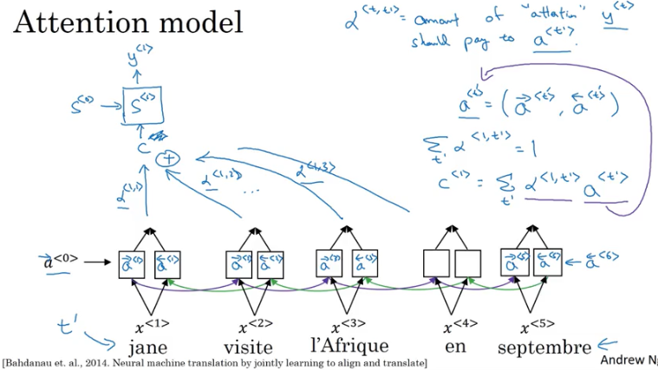

So the first time step, it should generate y1 and just will have as input some context C. C1 will depend on the attention parameters so alpha_11, alpha_12 and so on

And so these alpha parameters tells us how much the context would depend on the features we're getting or the activations we're getting from the different time steps.

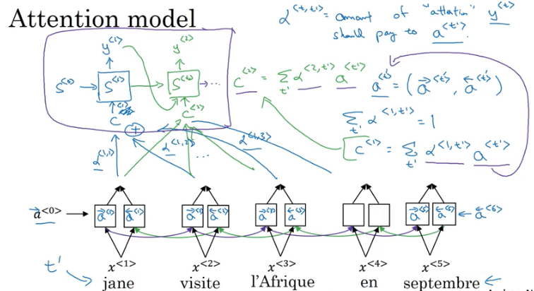

So using these context vectors. C1 right there back, C2, and so on. This network up here looks like a pretty standard RNN sequence with the context vectors as output and we can just generate the translation one word at a time.

We have also define how to compute the context vectors in terms of these attention ways and those features of the input sentence. So the only remaining thing to do is to define how to actually compute these attention waits.

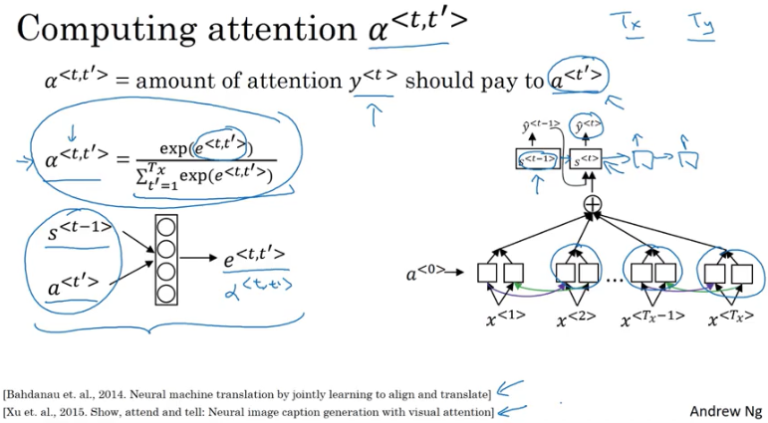

One downside to this algorithm is that :

* it does take quadratic time or quadratic cost to run this algorithm. If you have tx words in the input and ty words in the output then the total number of these attention parameters are going to be tx times ty. And so this algorithm runs in quadratic cost. Although in machine translation applications where neither input nor output sentences is usually that long maybe quadratic cost is actually acceptable. Although, there is some research work on trying to reduce costs as well.

This algorithm is also used in Image Captioning. Look at the picture and pay attention only to parts of the picture at a time while you're writing a caption for a Picture.

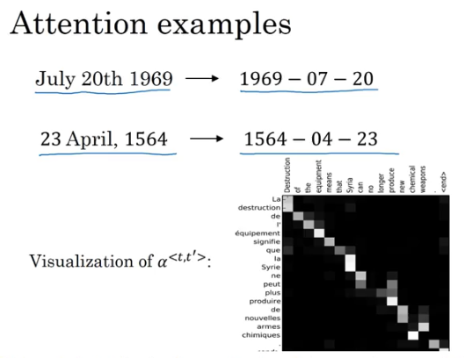

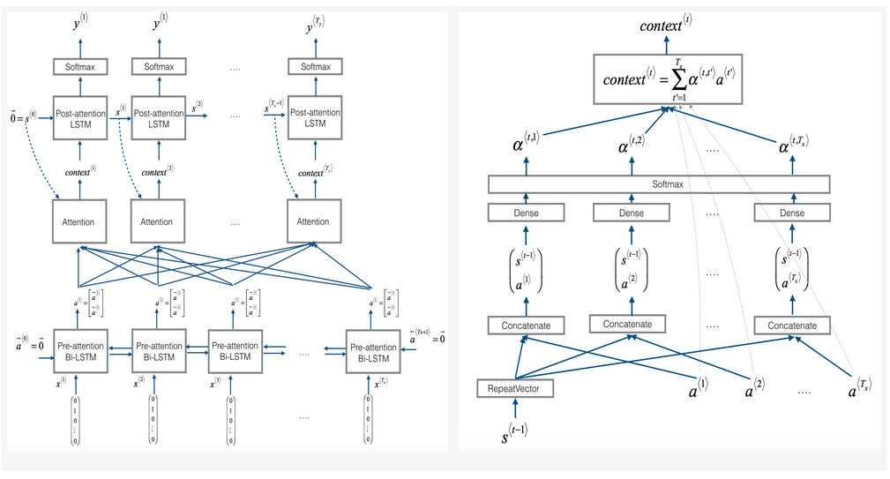

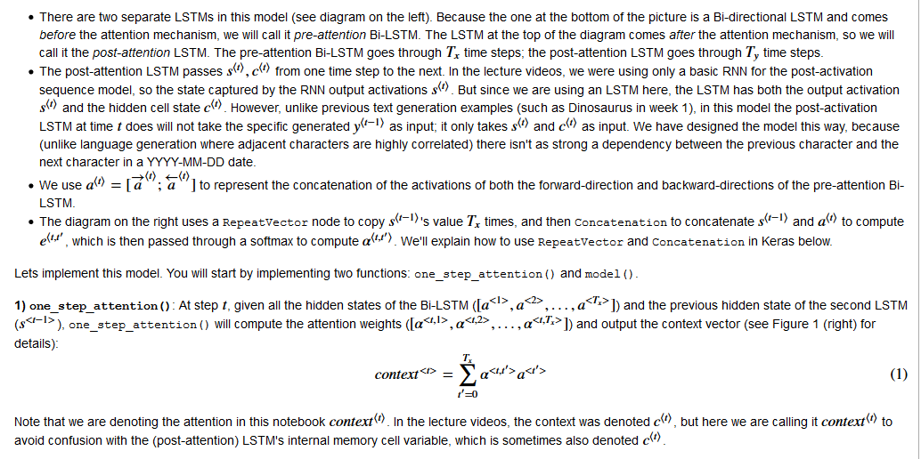

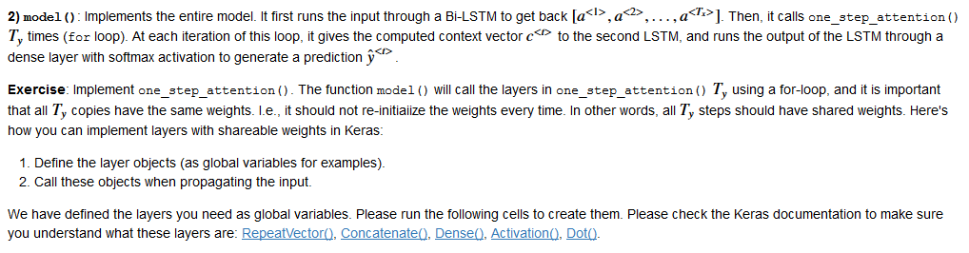

## Speech Recognition

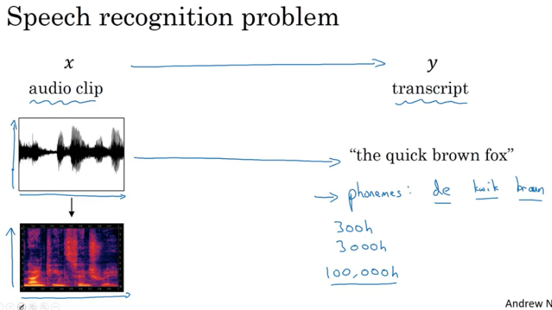

One of the most exciting developments were sequence-to-sequence models has been the rise of very accurate speech recognition

So, what is the speech recognition problem?

**You're given an audio clip, x, and your job is to automatically find a text transcript, y.**

So, an audio clip, the horizontal axis is time, and what a microphone does is it really measures minuscule changes in air pressure, and the way you're hearing my voice right now is that your ear is detecting little changes in air pressure, probably generated either by your speakers or by a headset.And some audio clips like this plots with the air pressure against time. And, if this audio clip is of me saying, "the quick brown fox", then hopefully, a speech recognition algorithm can input that audio clip and output that transcript.

And because even the human ear doesn't process raw wave forms, but the human ear has physical structures that measures the amounts of intensity of different frequencies, there is, a common pre-processing step for audio data is to run your raw audio clip and generate a spectrogram.

So, this is the plots where the horizontal axis is time, and the vertical axis is frequencies, and intensity of different colors shows the amount of energy.

So, how loud is the sound at different frequencies? At different times?

And so, these types of spectrograms, or you might also hear people talk about false back outputs, is often commonly applied pre-processing step before audio is pass into in the running algorithm. And the human ear does a computation pretty similar to this pre-processing step.

So, one of the most exciting trends in speech recognition is that, once upon a time, speech recognition systems used to be built using phonemes and this where, I want to say hand-engineered basic units of cells. So, the quick brown fox represented as **phonemes**.

I'm going to simplify a bit, let say, "The" has a "de" and "e" sound and Quick, has a "ku" and "wu", "ik", "k" sound, and linguist used to write off these basic units of sound, and try the Greek language down to these basic units of sound.

So, brown, this aren't the official phonemes which are written with more complicated notation,

but linguists use to hypothesize that writing down audio in terms of these basic units of sound called phonemes would be the best way to do speech recognition.

**But with end-to-end deep learning, we're finding that phonemes representations are no longer necessary**. But instead, you can built systems that input an audio clip and directly output a transcript without needing to use hand-engineered representations like these.

One of the things that made this possible was going to much larger data sets. So, academic data sets on speech recognition might be as a 300 hours, and in academia, 3000 hour data sets of transcribed audio would be considered reasonable size, so lot of research has been done, a lot of research papers that are written on data sets there are several thousand voice. **But, the best commercial systems are now trains on over 10,000 hours and sometimes over a 100,000 hours of audio**. And, it's really moving to a much larger audio data sets, transcribe audio data sets were both x and y, together with deep learning algorithm, that has driven a lot of progress is speech recognition.

So, how do you build a speech recognition system?

* One thing you could do is where on the horizontal axis, you take in different time frames of the audio input, and then you have an **attention model** try to output the transcript like, "the quick brown fox", or what it was said.

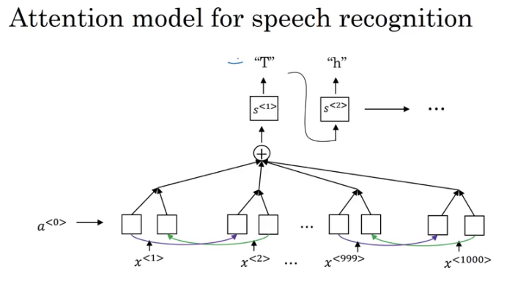

* One other method that seems to work well is to use the CTC cost for speech recognition.

### CTC(Connectionist temporal classification)

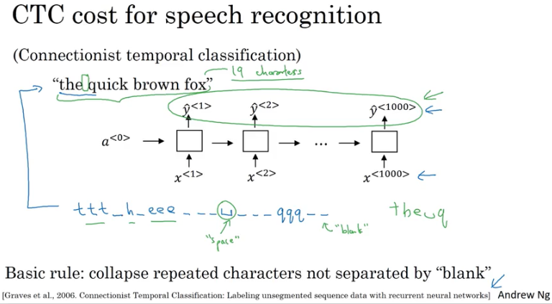

We're going to use a new network structured like this with an equal number of input x's and output y's, and I have drawn a simple of what uni-directional for the RNN for this, but in practice, this will usually be a bidirectional LSP and bidirectional GIU and usually, a deeper model.

But notice that the number of time steps here is very large and in speech recognition, usually the number of input time steps is much bigger than the number of output time steps.

So, for example, if you have 10 seconds of audio and your features come at a 100 hertz so 100 samples per second, then a **10 second audio clip would end up with a thousand inputs;But your output might not have a thousand alphabets, might not have a thousand characters.**

So, what do you do?

The CTC cost function allows the RNN to generate an output like this ttt, there's a special character called the blank character, which we're going to write as an underscore here

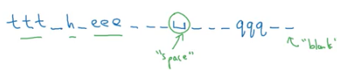

When the basic rule(collapse repeated chars not seperated by blank), the above set returns to this below:

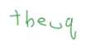

So, inserting a bunch of blank characters and still ends up with a much shorter output text transcript. So, this phrase here "the quick brown fox" including spaces actually has 19 characters, and if somehow, the newer network is forced upwards of a thousand characters by allowing the network to insert blanks and repeated characters and can still represent this 19 character upwards with this 1000 outputs of values of Y.

## Trigger Word Detection

examples

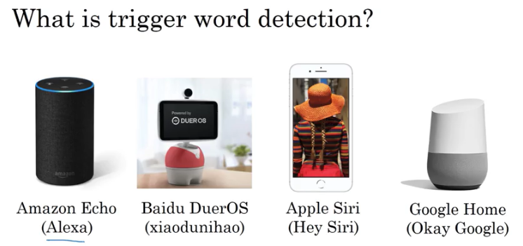

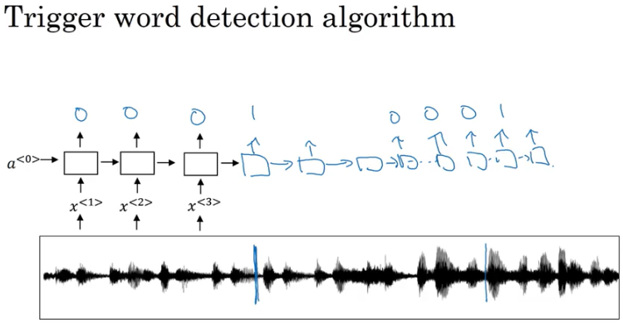

In the training sets you can set **the target labels to be zero for everything before the keyword**(hey siri etc) and right after that to set the target label of one and then if a little bit later on you know the trigger word was set again and the trigger was said at this point then you can again set the target label to be one right after that now this type of labeling scheme for an RNN you know could work actually this won't actually work reasonably well

One slight disadvantage of this is it creates a very imbalanced training set so if a lot more zeros than Ones 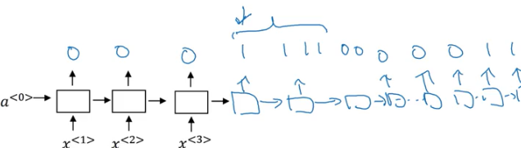  
so one other thing you could do that it's getting a little bit of a hack but could make them all the little bit easy to train is instead of setting only a single time step to output one you can actually **make an output a few ones for several times** or for a fixed period of time before reverting back to zero.